**MusixMatch 2.2.3**



**How does the program work and how does it work?**

A program that can use some algorithms to obtain music through the microphone, after which it is read and extracted the results from the sounds of the Qur’an, poem or music in general.

Who is using the app or who needs it?

Those who use the app or who need it are people who have some music and want to know more about it.

Advantages and Disadvantages:

-Some of the advantages

• Tracking the fast download feature of the subscribed user.

• Can read static characters from within a page.

• easy for use.

-Some of the Disadvantages

• Sometimes the lyrics are not accurate.

• Classical music instruments cannot be read.

• It may not be possible to get all the lyrics correctly.

**Proposed system (زياد الحوطي)**

A specific algorithm will be worked on, and it will be well developed, looking to be fast in extracting the voice of the reader, and a certain number will be taken, compared to the Holy Qur’an, and the voices to be extracted will be extracted faster.

**System requirements**

- If the system takes the voice of a reader, it sends it to the database, and then the voice of the reader is recognized and sent to the system.

- If the system does not recognize the voice of the reader, it will be saved in the database and will be trained in the upcoming passages.

- Mostly there are votes for the reader, but if it is new, a fingerprint is created for it based on the sample and it is compared in the central database for later matching

Linear Predictive Coding (LPC):

LPC is one of the most powerful speech analysis techniques and is a useful method for encoding quality speech at a low bit rate. The basic idea behind linear predictive analysis is that a specific speech sample at the current time can be approximated as a linear combination of past speech samples.

Mel Frequency Cepstral Coefficients MFCC:

The use of Mel Frequency Cepstral Coefficients can be considered as one of the standard method for feature extraction.

**Mel-frequency cepstral coefficients(MFCC):**

The road map of the MFCC technique is given below.

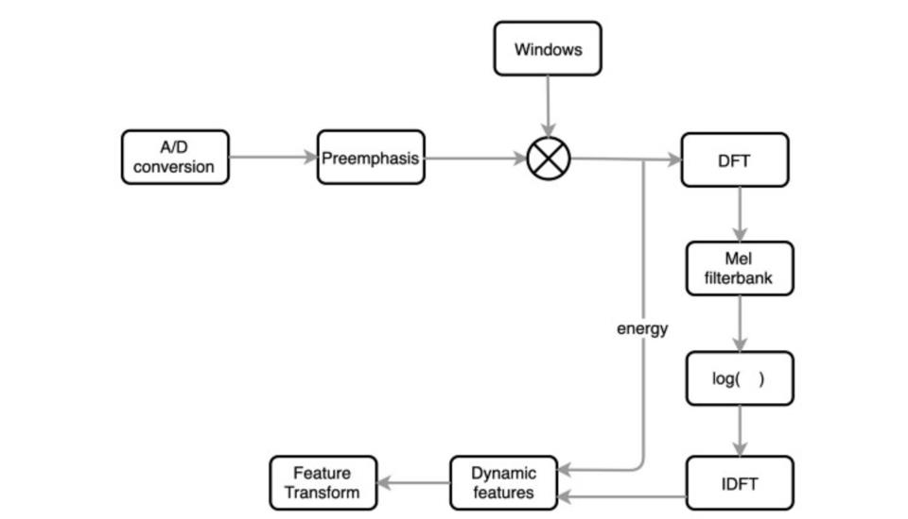

A/D Conversion:

In this step, we will convert our audio signal from analog to digital format with a sampling frequency of 8kHz or 16kHz.

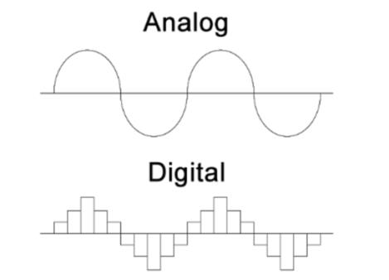

Preemphasis:

Preemphasis increases the magnitude of energy in the higher frequency. When we look at the frequency domain of the audio signal for the voiced segments like vowels, it is observed that the energy at a higher frequency is much lesser than the energy in lower frequencies. Boosting the energy in higher frequencies will improve the phone detection accuracy thereby improving the performance of the model.

Windowing:

The MFCC technique aims to develop the features from the audio signal which can be used for detecting the phones in the speech. But in the given audio signal there will be many phones, so we will break the audio signal into different segments with each segment having 25ms width and with the signal at 10ms apart

DFT (Discrete Fourier Transform):

Convert the signal from a field to a field (dft) for engineering signals, and the analysis is easier.

Mel-Filter Bank:

The way our ears will perceive the sound is different from how the machines will perceive the sound. Our ears have higher resolution at a lower frequency than at a higher frequency.

Applying Log:

Humans are less sensitive to change in audio signal energy at higher energy compared to lower energy. Log function also has a similar property, at a low value of input x gradient of log function will be higher but at high value of input gradient value is less. So we apply log to the output of Mel-filter to mimic the human hearing system.

IDFT:

Here he performs the inverse conversion of the output from the step before it, and we have to understand how the sound is produced by humans

Transfer function of the vocal cavity for different phones:

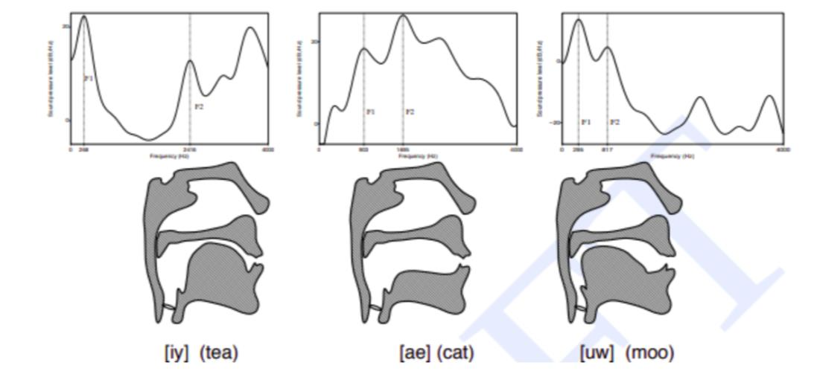

Dynamic Features:

It computes derivatives by coefficients among audio signal samples and helps understand the occurrence of the transition.